Northlandia Public Procurement Authority
Commercial Item Contract (Standard Tier)
Award Number: [Insert Number]
Supplier: [Insert Supplier Name]
Award Date: [Insert Date]
1. Contract Formation
This award document, together with the Supplier’s quotation dated [Insert Date], forms the entire agreement between the Parties for the supply of batteries and pencils.
2. Contract Items and Pricing
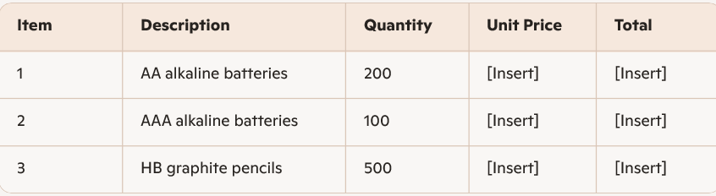
Total Contract Value: [Insert Amount]
Pricing is firm and fixed for the duration of the Contract
3. Delivery Requirements
- Delivery Location: [Insert Address]
- Delivery Deadline: Within 10 business days of award
- Delivery Terms: FOB Destination

4. Supplier Obligations
4.1 Performance Standard
The Supplier shall perform in accordance with industry standards and the requirements of this Contract.
4.2 Warranties
The Supplier warrants that all items will be new, free from defects, and conform to the specifications.
4.3 Risk of Loss
Risk of loss remains with the Supplier until delivery and acceptance.
5. Payment
The Authority shall pay valid invoices within 30 days of receipt. Invoices must reference the Award Number and itemize all delivered goods.
6. Liability
The Supplier is liable for direct damages arising from its performance. Indirect or consequential damages are excluded.
7. Termination
The Authority may terminate this Contract for convenience with written notice. The Supplier will be paid for accepted items delivered up to the date of termination.
8. Additional Provisions
- No hazardous materials are involved in this procurement.
- No intellectual property is created under this Contract.
- The Supplier shall comply with all applicable Northlandia laws and regulations.

